SV Carinthia

Welcome Aboard CARINTHIA !

In these pages, you will find information to aid in planning for   
departure and improve your enjoyment once aboard Carinthia.

CARINTHIA’s mission is to see the world !

This means that - the #1 characteristic crew needs is adaptability!

Boarding Rules

1. Everything that is on board stays on board – that includes you!
2. Bring ONE bag – soft duffel or foldable luggage and one personal bag.
3. No whining – or crying for that matter – the difference between an ordeal and adventure is your mindset
4. NO DRUGS !!!   
   NOT ON BOARD - NOT ON SHORE – NOT UNDER THE INFLUENCE OF – DO NOT EVEN THINK ABOUT DRUGS
5. If you think - you might get sea sick please - bring your anti-nausea medication – do not bring Dramamine – it makes you sleepy - and bring any medication you think you may need ... “Sturgeron” works very well … weather or other boating problems might prevent you from getting back at the anticipated time [see the #1 characteristic].
6. Personal electronic items – Even though we have electricity [AC 110 / 12 V DC ] on board - a 1200 watt air dryer can overload the boats electrical system – please bring only things that you must absolutely have plugged in – cell phones won’t work 5 miles offshore – but you can receive satellite phone calls ( we’ll provide the number once you board )

1. On board we do not wear shoes unless it’s night time or heavy weather- soft wool socks are great for cool climates – Crocks are great to get to and from shore.
2. The boat makes a lot of noises – some even sound like the boat is about to sink – which is not the case – so if you sleep light – bring some heavy duty earplugs – and / or an iphone /iPod.
3. We all have to assist in keeping the boat afloat so you will be asked to help with chores such as cleaning / cooking / night watches / etc. We do not ask of you anything that - we ourselves would not do / have not done. [ i.e. no whining]
4. Communication with the real world can be difficult at times – we suggest you set up an email broadcast list / list server – so that one email address forwards to all your friends and family at once – just be sure to add w d e 3 8 1 4 (at) s a i l m a i l . c o m [ remove the spaces and sub out the @ ] as an authorized email account.

# Boat Specifications

Vessel Name: C A R I N T H I A   
 Hailing Port: Las Vegas

Model: 440   
 Production Hull # 258

Manufacturer: Lagoon, France 2008

Registration Number: 1210260

LOA: 44' 8" 13,61 m

Beam: 25' 3" 7,70 m

Draft: 4' 3" 1,30 m

Displacement: 26,791 lbs 12,15 t

Mast Height: 71’

Water: 3 x 79 Gallons / 900 ltr

Fuel: 2 x 86 Gallons / 650 ltr   
 [+ 152 w jerry cans / blad.]

Hull Material: Fiberglass

SSB call sign WDE3814  
 Hull ID: CNB442581708

USCG # 1210260

Liferaft 8 Person Viking Rescue Life Raft

Dinghy 4 Person EWVG1224A707  
 Engines x 2 Yanmar 2007 54hp Diesel   
 Dinghy Engine Tohatsu 9.9 Gasoline ( old )   
  
Contact Information:

* SSB call sign WDE3814 / HAM KF7RGT
* EBRIP UIN 2DCC569C5AFFBFF
* MMSI 338077017
* [dietmar@52hertz.com](mailto:dietmar@52hertz.com) [suzanne_a_dubose@yahoo.com](mailto:suzanne_a_dubose@yahoo.com)
* Ship FIJI CELL + 679 862 0418

Emergency Numbers:  
  
 *US COAST GUARD*

* SAN DIEGO 619-278-7030
* COMMANDANT 202-372-4411
* GLOBAL 202-372-3055
* USCG Lt. J. Grant Thomas 502-649-0951
* Whitehouse Switchboard 202-456-1414
* Navy Public Affairs 650-603-9655
* Intl. Piracy Hotline +603-2031-0014

*RCC New Zealand*

* Lower Hut +64 4 577 8030 [RCCNZ@maritimenz.govt.nz](mailto:RCCNZ@maritimenz.govt.nz)

STANDING ORDERS !

1. No peeing overboard EVER
2. No sail changes by yourself
3. No reefing by yourself
4. No mayor course changes by yourself (+/- 10 deg)
5. Nobody opens the freezer – First mate only
6. In elevated seas or offshore life vest must be worn
7. Alert Captain if offshore and other vessel is in close proximity ( under ½ nm )
8. Use manual winch at night
9. You must read and confirm that you read and understood this document
10. Alert Captain if you sense that there is anything wrong
11. No swimming or jumping overboard while underway

# Boat Overview Thru-hull Locations ● [red dots - below waterline] Thru-hull Locations ● [green dots - above waterline] If the boat suddenly takes on water – it may be that one of these red through hulls is malfunctioning – a simple wooden plug will stop water from sinking CARINTHIA – we have plenty of wooden plugs onboard ;-) most through hulls have them next to them on a blue lanyard additional plugs are in the aft emergency locker

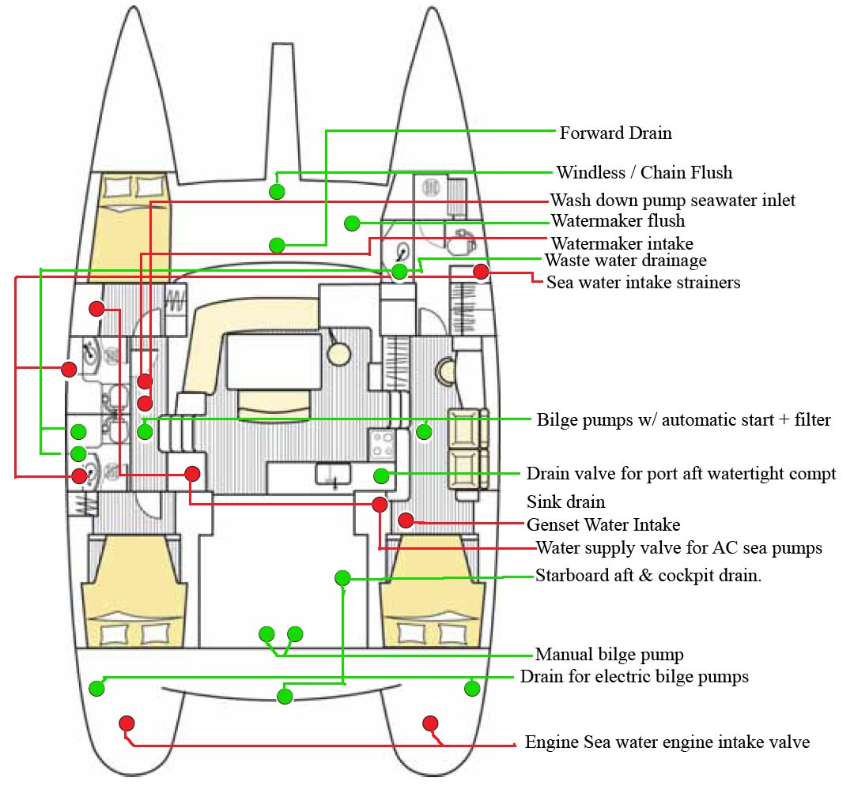

4 Starboard - with tapered wood plugs [USE RUBBER MALLET TO DEPLOY]

Captains Quarters 2 through hulls with wood plugs under floorboards

For AC Intake / Genset Intake and 1 throughullsnext to head for head intake

1 under sink for Waste Water Drainage /

7 Port - with tapered wood plugs [USE RUBBER MALLET TO DEPLOY]  
 3 Forward Head through hulls 2 Drains 1 Freshwater Intake for head

1 Aft Head Freshwater through hull

2 Under floorboards through hulls for watermaker and wash down pump

1 Aft Cabin under floorboard for AC Sea pump distribution port side

2 additional through hulls in each engine compartments on port & starboard side

Crew Training Outline

## Boat Safety and Emergency Management

All crew must be knowledgeable and proficient in the boat safety and emergency management topics:

1. Thru-hull locations and emergency leak search and shut-off procedure
   1. Review location of all thru-hull locations and know how to use tapered wood plugs to stop leaks
   2. Review how to turn off and on thru-hull valves
   3. Practice turning thru-hull valves on and off
   4. Memorize which position is open and which position is closed
   5. Review hard to see valve locations behind main engine
2. Fire Aboard Procedures
   1. Engine Fire
      1. Turn off batteries
      2. Turn off fuel at tank
      3. Locate nearest fire extinguisher
   2. Galley Fire
      1. Use galley fire extinguisher first
   3. General fire notes
      1. Aim extinguisher at base of flames
      2. Do not open engine compartment if there are flames
      3. Insert fire extinguisher nozzle into hole in
3. Emergency Locations – Review and memorize location of all items

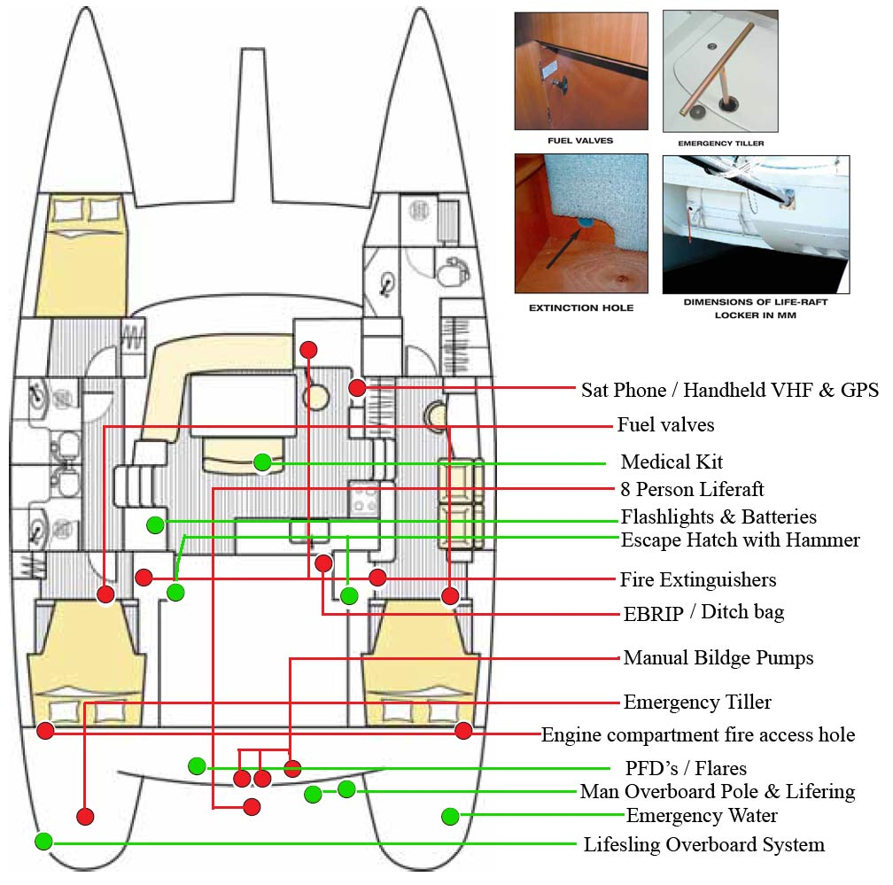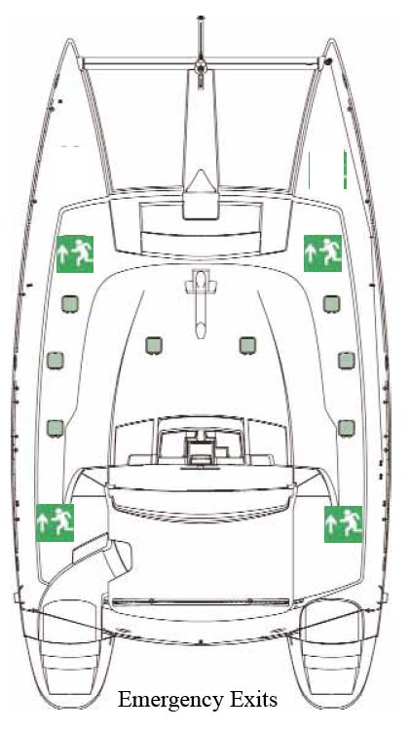

Emergency Locker Offshore Ditch Bag Emergency Water 20L Jug  
  
8 Person Life Raft EBRIP Sea Anchor   
  
  
Fire Extinguishers First Aid Kit 2 Drogues

Fire Blanket Emergency Communications Station

SAT / SSB / VHF / SAT2 / CELL / AIS / GPS

1. EPIRB deployment scenarios and how to turn on

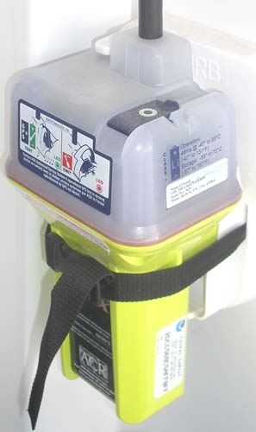

* 1. Only deploy the EPIRB on the direction of the captain
  2. Overview - Transmits on 406 MHz via the COSPAS-SARSAT satellite system with a registered unique, digitally coded distress signal and 121.5 MHz (SAR homing frequency) Floats to avoid loss if dropped in water, On board GPS acquires LAT/LON when the unit is activated, your LAT/LON are transmitted as soon as acquired providing rescue agencies with your exact position to within 110 yards. This Beacon should only be used in situations of grave and imminent danger, and only as a last resort when all means of self-rescue have been exhausted.
  3. The EPIRB is located in the aft area at eye level
  4. Instructions for use
     1. To deploy while on the boat, flip the tab all the way over
     2. To deploy in the water, place in water and spool out lanyard and attach to dinghy or boat

1. Ditch bag contents review and emergency scenarios
   1. Contents of the ditch bag are designed to allow the crew to survive off the boat. Ditch bag includes emergency provisions, emergency signaling devices, and VHF radio.
   2. A crew member will be assigned responsibility for the ditch bag. At the captains direction, the assigned crew member will bring the ditch bag on deck and lash it into the dinghy / life raft
   3. The same crew member will be responsible for grabbing the EPIRB and placing it in the ditch back while bringing the bag on deck. The EPIRB is located at the aft compartment
2. Crew Overboard Training MOB
   1. All crew members must be proficient in crew overboard procedures.
   2. Refer to *Basic Keelboat* training manual for details
   3. Essential Skills
      1. Deploying the Man Overboard pole
      2. Deploying the throwing line & flashing indicator
      3. Deploying the floating ring
      4. Finding a crew overboard
      5. Using the floodlight
      6. Using the Lifesling to bring them on board
3. Medical issues and emergencies
   1. There is a comprehensive first aid kit onboard and a Medical Manual for diagnosing a wide variety of conditions.
   2. First aid kit is in the main cabin under the seating area
   3. In case of emergency, it is important for the captain to know of any medical conditions that might be relevant while you are on board.
      1. If you are comfortable disclosing these conditions, please do so.
   4. If you are not comfortable disclosing a medical condition, please write down the condition and any relevant information and seal in an envelope and let the captain know where the envelope can be found in an emergency
   5. Take care of small cuts and abrasions – they can easily become infected in hot, tropical environments and if you are in the water much.
4. Abandon ship procedure
   1. “*Always step UP from your boat into the life raft”*
   2. If sea or boat conditions warrant preparation for abandoning ship, the captain will give orders to prepare to abandon ship. Common reasons to abandon ship are:
      1. Water coming in the boat faster than the bilge pumps can pump it out
      2. Boat on the rocks and in danger of breaking up
      3. Boat immobilized and in danger of collision with commercial shipping traffic
   3. Preparing to abandon ship
      1. Each crew member brings only necessary items
         1. Clothing for survival
         2. Passport and other documentation
         3. PFD / Life vest
      2. Assigned crew member grabs ditch bag and EPIRB and lash into dinghy / life raft
      3. Assigned crew member prepares dinghy / life raft for loading and lashes to boat at captains direction
         1. If possible, attach outboard motor to dinghy / Life raft
      4. Assigned crew member radio’s for help on VHF
         1. Mayday-Mayday-Mayday
         2. This is the sailing vessel CARINTHIA   
            [ CHARLIE ALPHA ROMEO INDIA NOVEMBER TANGO HOTEL INDIA ALPHA ]
         3. Our location is (latitude/Longitude or # miles northwest of [landmark]
         4. We have # people on board
         5. List injuries or crew condition
         6. “We intend to abandon ship”
         7. Await response – ability of responder to come to our aid
         8. Repeat until command to abandon ship
         9. Note responding ships location and time to arrival
   4. Abandoning Ship
      1. Await the captains order to abandon ship
      2. Deploy sea anchor / drogue to ship
      3. Assigned crew member holds the dinghy close to the boat
      4. Crew enters the dinghy / Life Raft
      5. Captain enters the dinghy / Life Raft
      6. Push away from the boat
5. Crew Emergency Assignments
   1. During an emergency, each crew member will be assigned specific responsibilities, mainly having to do with an orderly evacuation of the boat.
   2. Each crew member will have primary and secondary responsibilities. Secondary responsibilities are to be accomplished if the primary person responsible for the task has become incapacitated.

|  |  |  |
| --- | --- | --- |
| Crew Member | Primary Responsibility | Secondary Responsibility |
| Dietmar | Overall Orders  Boat Triage, FireFighting  Emergency Communication |  |
| Suzanne | Ditch Bag  EPIRB Deployment & GPS INFO & Vienna |  |
| Crew | Boat Triage, Flares Deployment, Life Raft & Dinghy Deployment & Ditch Bag, Fire Fighting |  |
|  | | |

* 1. Emergency Task Description

|  |  |
| --- | --- |
| Boat Triage | Figuring out what is wrong with the boat and finding a way to keep it afloat. Directing crew in triage activities and ensuring primary responsibilities are fulfilled |
| Emergency Communication | Using VHF and/or Satphone to call emergency services |
| Life Raft & Dinghy Deployment | Prepare the dinghy / life raft for boarding. Make a decision on whether the engine can be mounted. Tie off dinghy to stern and await orders to board. |
| EPIRB Deployment | Grab both EPIRBS and prepare to deploy at captains orders. DO NOT DEPLOY UNLESS DIRECTED |
| Ditch Bag | Grab the ditch bag and bring ditch bag onto life raft / dinghy |
| Flares Deployment | Grab flare box and bring to helm station. Open box and prepare flares for firing |

## 

## Boat Systems

All crew should be familiar with the following areas. However, it is not necessary to know this information to the same degree as the safety information above.

1. Electrical Panel Review and power management
   1. AC [110 v] vs. DC [12 v] systems
   2. AC systems – The generator provides AC power to high consumption items like hot water heater, microwave, hair dryer, Watermaker, washer and dryer. Low power consumption items like laptops, cell phone chargers can be plugged in at any time.
   3. Notify the captain or first mate before running generator
   4. If the main battery voltage gauge on the electrical panel reads under 12 volts,/ 50% of battery power care should be taken. The generator or main engine needs to be run to recharge the batteries
   5. If battery voltage gets below 50% or 12 volts, the generator must start and needs to run until we reach at least 80%.
   6. To conserve power, use LED lights when possible and turn off lights that are not in use
2. Storage compartment review
   1. Review location of all public storage compartments
   2. Review requirement to close latches securely
   3. Turning off compartment lights
3. Electric head usage & water management
   1. The electric toilets in the head have two switches, one adds water to the bowl, the other flushes
   2. The toilets will not flush without the water breaker switch on the electrical panel turned on
   3. Use minimal amounts of toilet paper,- 4 sheets per flush max - as the built in macerator in the toilet can clog
   4. If debris remains in the toilet after flushing, use brush and vinegar/water spray bottle to assist cleaning
   5. If you have (or think you will have) difficulty flushing, call the captain or first mate before proceeding. Don’t be embarrassed!
   6. Fresh water is a very precious resource – don’t overuse water – one quick shower with fresh water a day – if you decide to go snorkeling – or swimming in the morning and again in the afternoon you may only rinse once and take ONE shower per day – to make water takes resources and we never want to be left without freshwater. Please be considerate.
   7. If for some emergency reason we cannot make fresh water or procure fresh water otherwise - we will institute a fresh water rationing plan which you MUST obey - to save the crew and ship.
4. Emptying Head Holding Tanks [ 3 miles off shore or more ]
   1. The heads dump into separate holding tanks.   
       If outside 3 miles from territorial waters,  
       the tanks can be dumped overboard
   2. Procedure once outside the 3 mile zone  
      1. Open thru-hull valves [ there are 3 of them one for each head ]
      2. Go aft to monitor brown water discharge
      3. Wait 5 minutes
      4. Close thru-hull valves

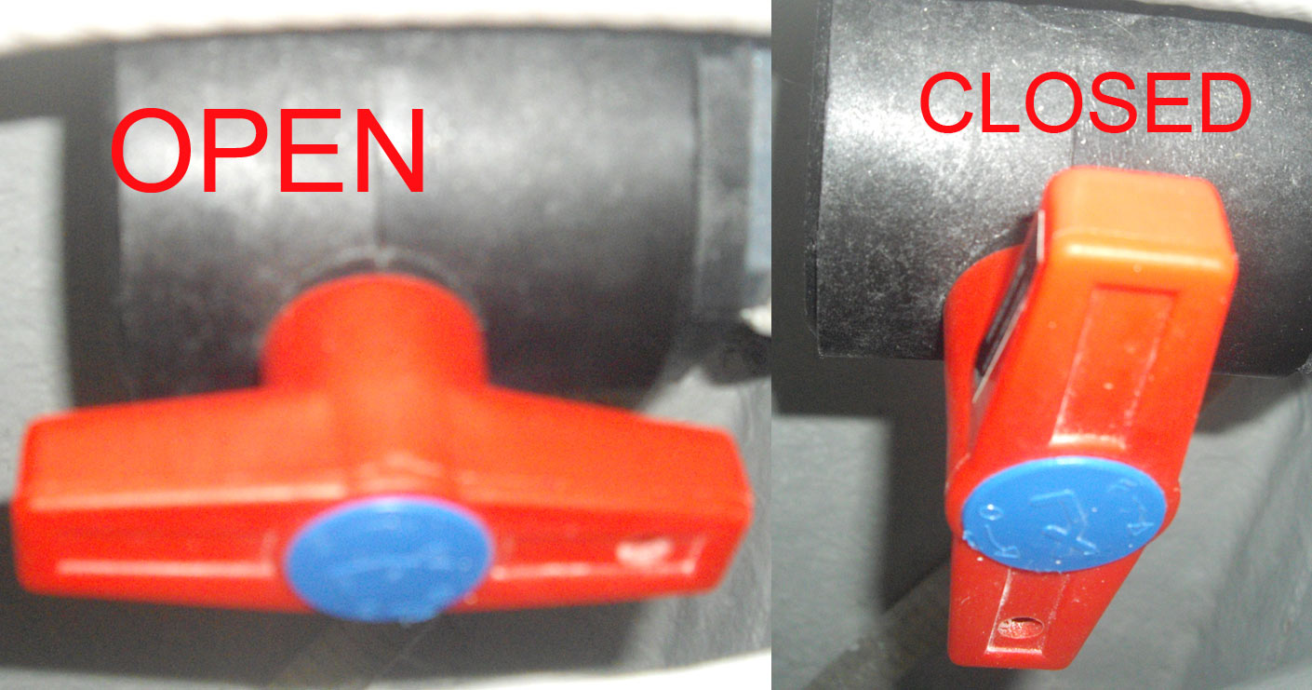

1. Generator start/stop procedure
   1. The genset is required to run hair dryers, clothes washer, prolonged microwave use, air conditioner and battery recharging
   2. The genset start/stop switch is located at the nav station
   3. Warn the crew before starting the genset
   4. Pressing start HOLDING IT DOWN FOR 20 SECONDS will begin the startup process [The orange indicator light will flash until the genset starts]

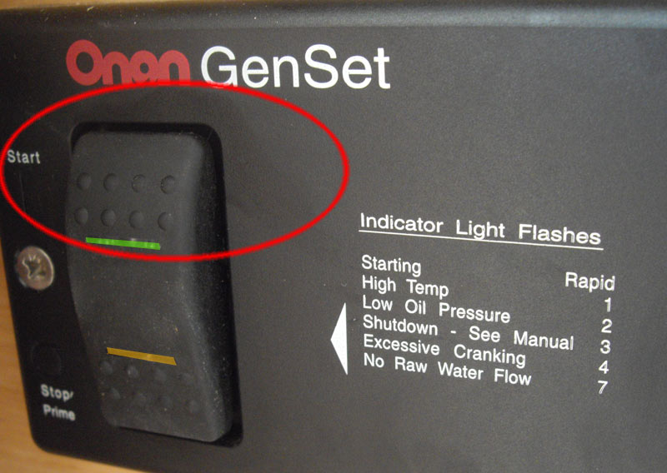

* 1. You will hear the fuel pump cycling followed by the Genset starting
  2. Now you need to switch the main fuses – below the Genset controller -from SHORE TO GENSET

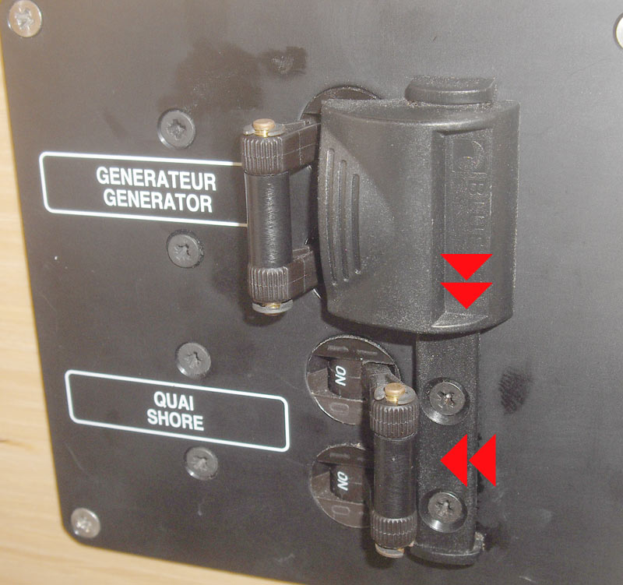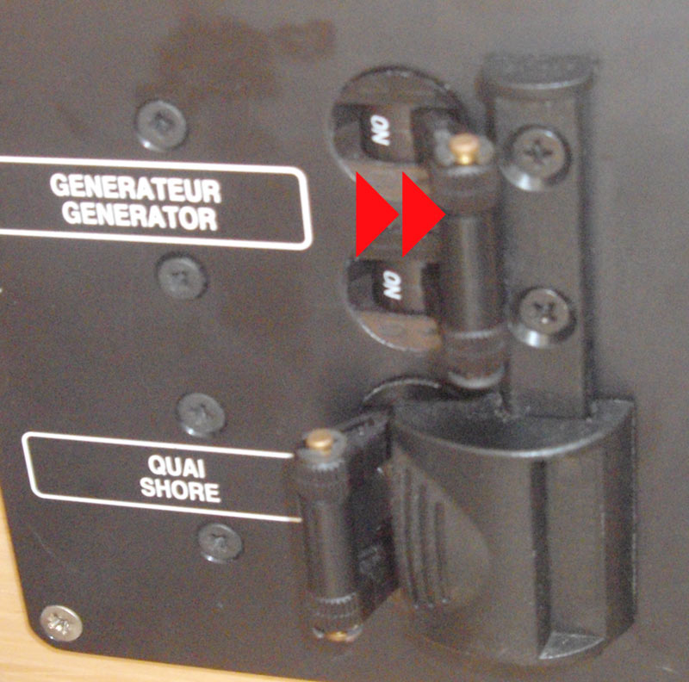

* 1. To Stop the Genset Press the stop button.  
     The genset will stop immediately.  
     Reverse the main fuses if going on / back to shore power.

1. Electricity usage and monitoring  
   1. Battery condition and available capacity can be viewed on the control panel at the electrical panel station.
   2. Select the METER button and use the dial to go to 02 then PUSH the

Rotary dial IN – you will see a % of total charge

* 1. Batteries should not be run to less than 50%. If approaching 50%, the genset or engine should be run to recharge the batteries if the sea state allows for it.
  2. Review LED lights vs. halogen lights.
  3. Generator will be run as required to make water and recharge batteries.

ON SHORE POWER OFF SHORE POWER

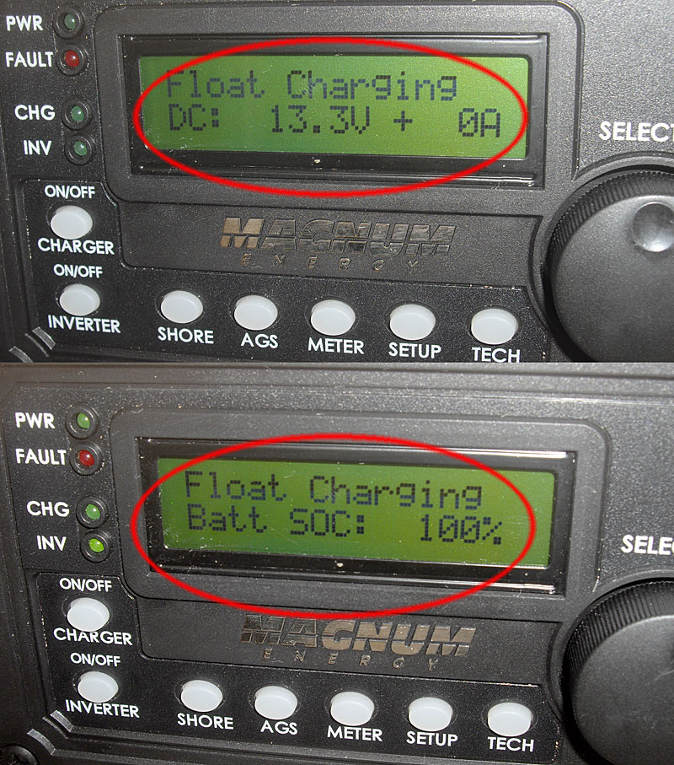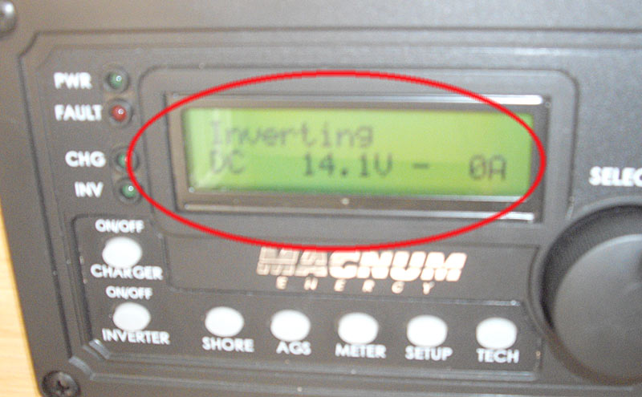

Sail Handling

1. Points of sail
   1. Review points of sail and sail positioning for each
2. Helmsman ship
   1. Review helm handling
   2. Review autopilot basics
   3. Sailing a compass heading
   4. Securing the helm at anchor [screw]
   5. Commanding the crew
   6. Responsibility for crew safety and managing the boat in the water
3. Tacking
   1. Filling positions at each winch when initial command given
   2. Reviewing commands
      1. “prepare to tack”
      2. “tacking”
   3. Sail trimming after a tack
4. Jibing
   1. Filling positions at each winch when initial command is given
      1. jib sheets
      2. Main sheet
   2. Reviewing commands
      1. “Prepare to jibe”
      2. “Pull in the main”
      3. “Jibe Ho”
      4. “Ease the main”
   3. The dangers of an uncontrolled jibe
      1. Not controlling the main
      2. Getting hit by the boom
      3. Damaging the boom
      4. Falling overboard / MOB
5. Crew communication and coordination
   1. Being aware of the boat’s condition at all times
   2. Anticipating sail trimming
   3. “All hands on deck” - horn
   4. Role of the helmsman in controlling the crew
6. Rigging preventers
   1. Running the preventer to the beam cleats
   2. *Release the preventer* before tacking or jibing,  
       hoisting or dousing the mainsail
7. Furling in/out the jib
   1. Managing the furling line
   2. Make sure not to furl in too much
   3. Two wraps on the sail
   4. Controlling the jib sheets while furling
8. Raising and dropping the main sail
   1. Using the Halyard
   2. Releasing the Preventer
   3. Releasing the Reef Lines 1 and 2
   4. Checking the downhaul
9. Flying the spinnaker
   1. Rigging the spinnaker
   2. Points of sail for the spinnaker
   3. The danger of wraps
10. Flying the Genaker [ Code 0 ]
    1. Rigging the Genaker
    2. Points of sail for the Genaker
    3. The danger of wraps
    4. Cover the Genaker
11. Reefing the main and jib
    1. Reviewing Reef points on the fly bridge
    2. Reef early & often

< 18

c. If seas are rough 3m+ and forward - fall of and run off @ 140° of the wind

22

20

19

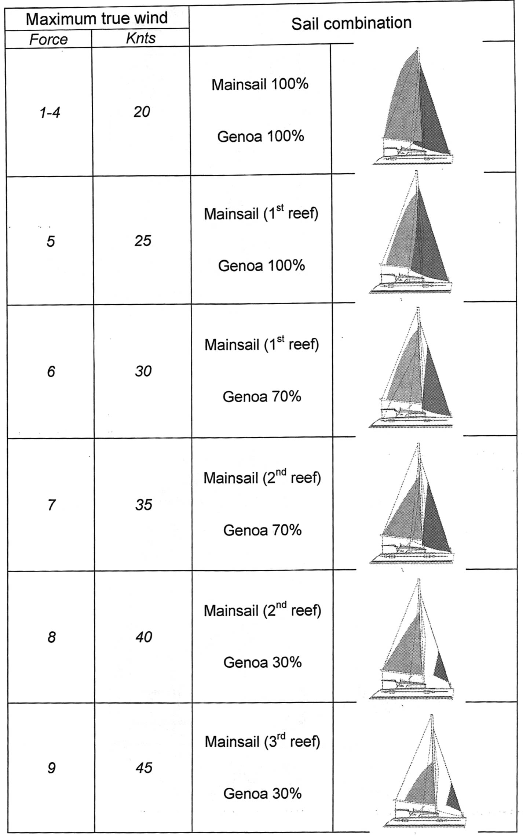

25

27

30 -35

BEYOND 35 KNOTS ?  
Drop the Main use stack pack as a storm sail and a tiny jib [ 4th dot ]

RUN OFF the wind at ~ 140°

1. Checking the Rig and Shrouds

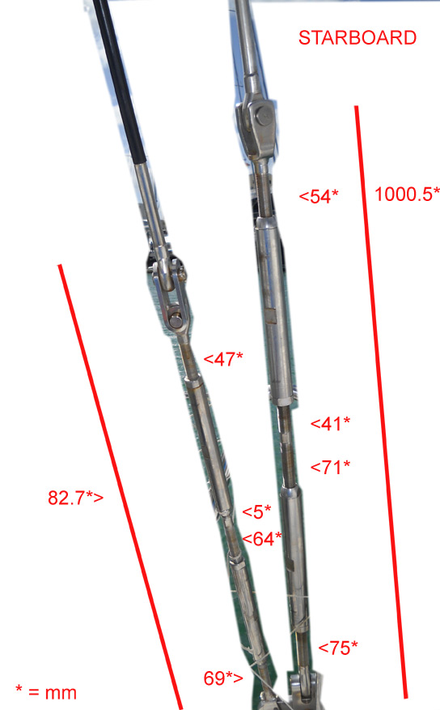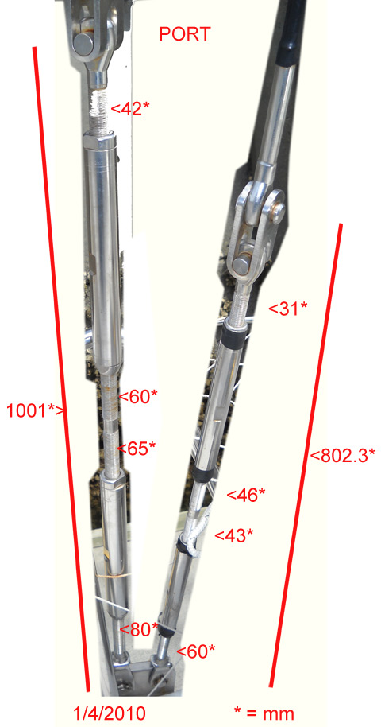

Before getting underway check the rig / and shrouds – below are typical settings after a rig tune – the shrouds feel strong but not overly tight

1. Use of PFD’s
   1. During the day
      1. As conditions dictate
      2. The captain and/or helmsman controls the decision
   2. At Night
      1. PFD’s are mandatory
      2. Tethers and lifelines during late night watches
      3. PLB and VHF attached to PFD
2. Heaving to / Drogue deployment / Sea anchor deployment
   1. Practicing Heaving to / Drogue deployment / Sea anchor deployment
   2. Scenario’s for Heaving to / Drogue deployment / Sea anchor deployment

## Anchoring

1. Windlass switches and breakers
   1. Ensure Engine is on
   2. Windlass breaker in front locker [ Watermaker] if windlass does not work
   3. Too much stress on windlass while bringing in anchor can trip breaker / release all the chain.
   4. Snubber / Bridle deployment
2. Setting Anchor
   1. Dropping anchor while moving to stern
   2. Formula’s for anchor rode scope 7:1
   3. Backing down to ensure a good set
   4. Anchor Rode Colors Schema marked with zip ties every 10 feet   
        
       0 - 50 Feet BLUE   
       50 - 100 Feet YELLOW  
      100 - 150 Feet PURPLE  
      150 - 200 Feet RED  
      200 - 220 Feet WHITE
3. Anchor retrieval
   1. Hand signals
   2. Bridle / Snubber
   3. NOT overstressing windlass
   4. Positioning the anchor on the bow rollers
4. Using the bridle & snubbers
   1. The concept
   2. bridle & snubber setting practice
5. Dragging anchor procedure and anchor watches
   1. How to tell if you are dragging
   2. In winds over 25 knots we may deploy an anchor watch system similar to overnight watches the goal is to monitor the boat. First we place 3 white fenders on the bow which can be deployed quickly even if another boat is dragging on us - If Carinthia is dragging beyond the safety zone – or if another boat is coming to dangerously close to us – thats usually 80 feet for us ] start the engines - and wake all aboard and place the fenders in the general area where a collision might occur.

## Getting Underway

1. Securing the cabin
   1. See checklist
   2. Cabin walkthrough
   3. Securing the TV’s
   4. Turning on instruments
2. Engine Checkout
   1. Checking oil
   2. Checking coolant level
   3. Checking for water in the fuel filter
   4. Checking Exhaust after engine start
3. Line Handling
   1. Securing lines
   2. Letting the cleat do the work
   3. Taking direction from the helmsman
   4. Casting off based on commands
4. Throttle controls
   1. Gentle movements while going forward
   2. Aggressive movements during close handling
   3. Watching the speed / tachometer
5. Switching primary fuel filters while underway  
     
   Check the Primary Fuel Filter Indicator -   
   If the follow indicator [ big red big needles moves up towards the Threshold indicator needle it’s time to change the primary fuel filter

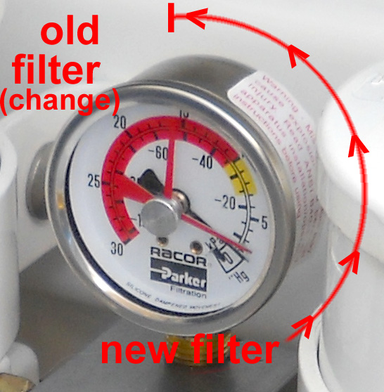

To switch from A to B primary fuel filter follow these steps

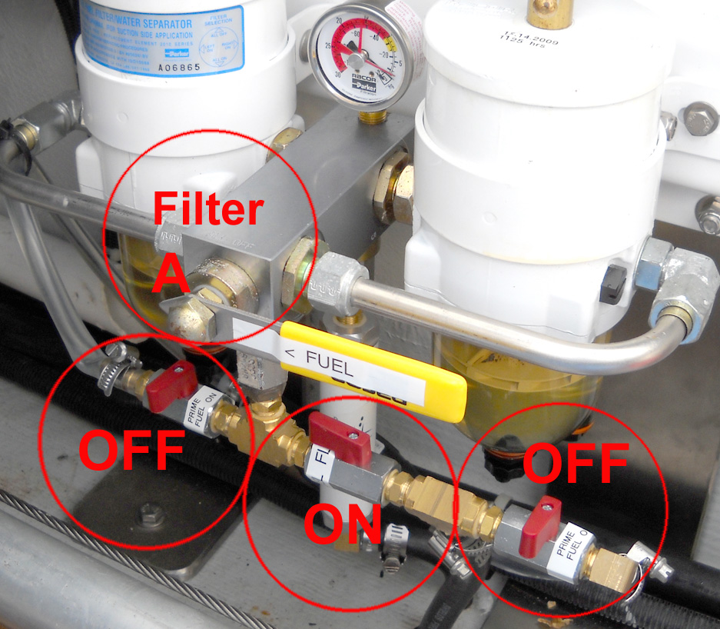

Normal Operation on Filter A

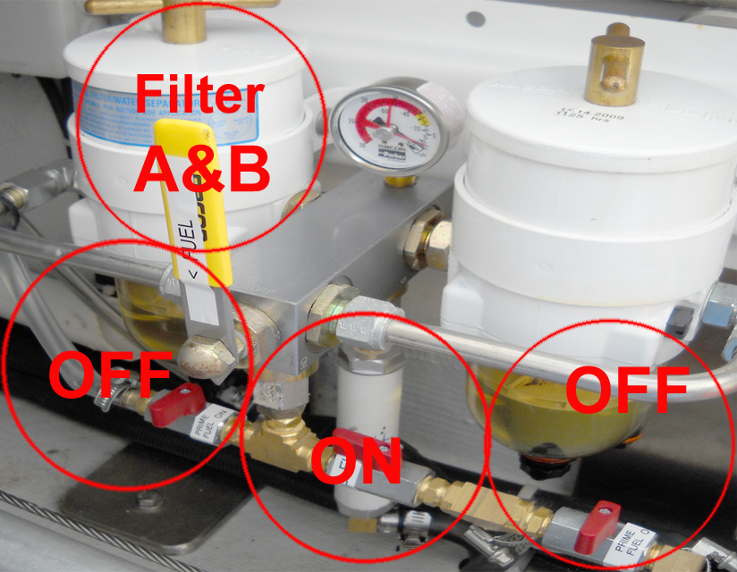

* 1. Stop engine
  2. Move the Filter Select Lever to A&B
  3. Swap out dirty filter element / replace element and both o-rings

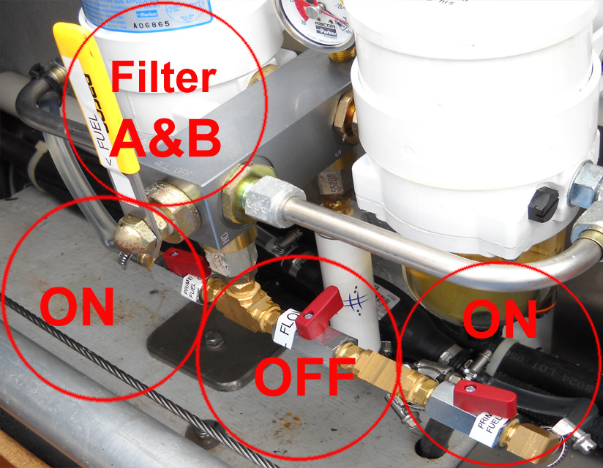

f) now turn of fuel thru switch [ center ]

g) open both prime switches on the left and right side of the fuel thru switch

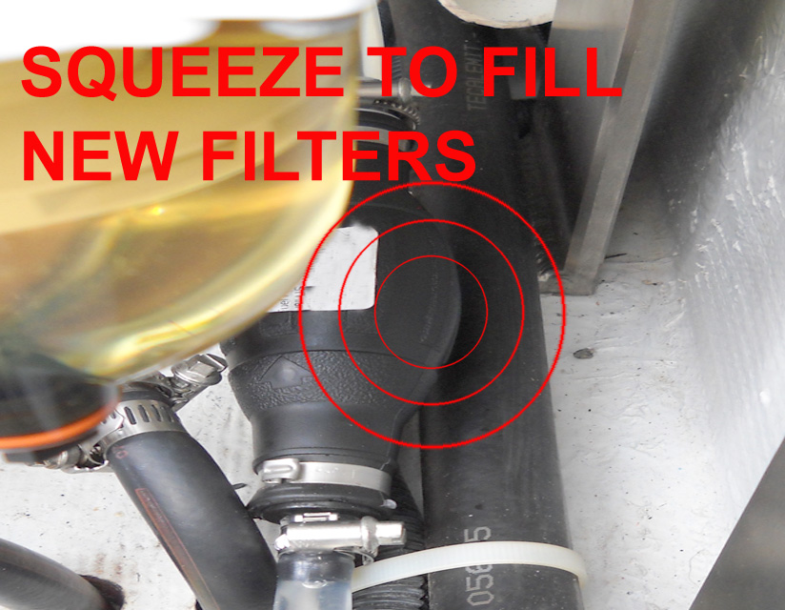

h) squeeze priming bulb until the level for both primary fuel filter elements has reached the top rim

i) close the filter element housing covers

j) reverse switches back to



k) Select the new primary filter to use [ A or B ]



Voila / buy a new 30 micron element in port to replace the old one

## Boat Handling/Helm Skills

1. Controlling the boat
   1. “Slow is pro”
   2. Using both throttles
   3. Windage
   4. Drifting
2. Giving direction
   1. Helmsman controls the boat and the crew for boat handling
3. Boat Log Procedures
   1. Every 3 hours under way
   2. Reviewing the log
4. Monitoring engine vitals & rigging
   1. Watching gauges
   2. Listen for changes in engine tone
   3. Watching behind the boat for kelp, crab pots, etc
   4. Be aware of any differing smells - ie could be coolant etc. *
   5. Listen for any noises from rig or otherwise that are 'new' *

Noise generally indicates chaff -

* Always report anything unusual to oncoming watch create a log entry.

## Roles and Responsibilities

1. Captain - Captain is the legal status of the master of a ship at sea and, on most legal documents in the merchant shipping industry, he or she is referred to as the Master. As the commander of a vessel under way, a nautical captain has enormous legal powers, including the right to use deadly force to suppress piracy and mutiny. Mutiny is not simply the crime of disobeying the lawful orders of a nautical captain at sea, but rather doing so with the intent of taking over the ship.
2. Navigator - A navigator is the person onboard a ship responsible for the navigation of the vessel. The navigator's responsibilities include planning the journey, advising the captain while en route, and ensuring that hazards or obstacles are avoided.
3. Purser – The purser is responsible for the overall coordination, maintenance and safety of the cabin and it’s systems, including making sure all assignments are completed as expected, looking out for issues and general cleanliness below deck.
4. Rigger – The rigger is responsible for overall readiness, maintenance and safety of on-deck systems, including standing and running rigging, lifelines, anchor systems, jacklines, preventers, sails, etc.

## Privacy On Board

1. Personal space and time
   1. Using cabins for personal time
   2. Using the foredeck for personal time
2. Managing personal effects
   1. Keeping personal effects out of public areas
   2. Heads and shower coordination

## Maintenance and Daily Upkeep

1. Rotating roles and responsibilities
   1. Schedule TBD

## Watermaker and Water Preservation

1. Checking water levels
   1. Turn on the breaker for the water gauge
   2. Make water if tanks are below 25 %
2. Starting/stopping the Watermaker
   1. Water maker can only be run with the generator
   2. Boat speed must be below 8 knots and not heavy seas.
   3. Boat must be out of harbor or other dirty water areas and not at anchor
   4. Start the generator
   5. Turn on the Watermaker fuse
   6. Press the start button on the panel on the nav station
   7. Check to ensure red light does not come on – if it comes on, it usually happens within first 20 seconds
   8. Check water levels every 30 minutes
   9. Turn off water maker with stop button
   10. If water maker does not start, check breaker in main control panel
3. Water use & preservation
   1. Shower – turn off water after getting wet, then soap up, then rinse
   2. Make sure sump pump is on [ you’ll hear it go off ]  
      & Clean the sump pump filter once a week

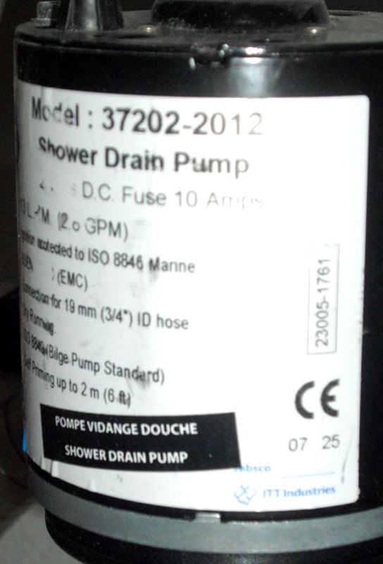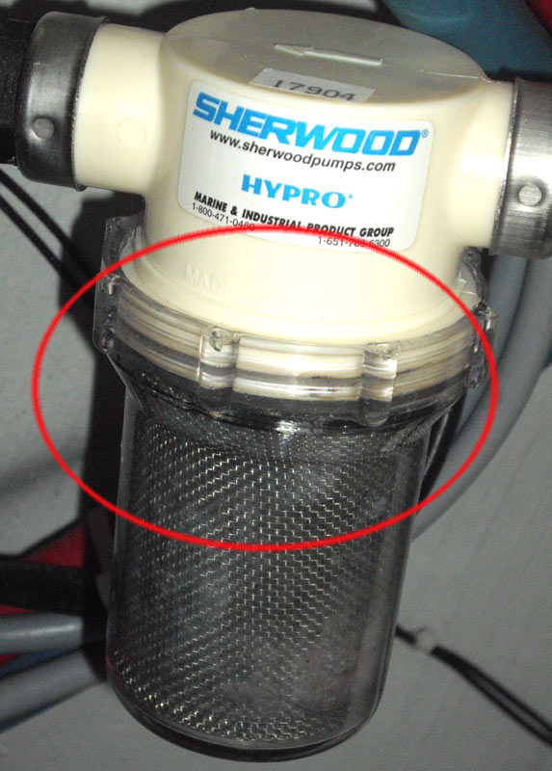

* 1. The less water we use, the less the water maker needs to run, means less generator time, means less noise

## 

## 

## Night and/or Heavy Weather Sailing

1. Use of tethers in the cockpit
   1. Tethers are required during night or heavy weather sailing.
   2. PFD’s and tethers must be on BEFORE coming on deck
   3. Hook in to cockpit tether hook before coming on deck
2. Going forward
   1. Must have permission of helmsman before going forward
   2. Must hook into jacklines
   3. Must move forward on high side of boat
3. Quiet courtesy during overnight legs
   1. Tether hooks make a lot of noise. Pick it up while moving around deck

## Food and Alcohol

1. Snacks vs. meal foods
   1. Raiding the fridge
   2. Snack cabinet
2. Alcohol and shifts
   1. Daytime vs. night time
   2. Moderation under way

## Cost Sharing

1. Shared expenses
   1. Joint provisioning ~allocate about 50 USD per person per day
   2. Food * [basic food is provided
   3. Beverages, Coffee, Tea, Water, Soda, Juices
   4. Shore Licenses / Immigration fees / Personal Customs Fees
   5. Transportation to / from Marina if going to provision
   6. Fuel for dinghy and diesel for vessel
   7. Propane for cooking
2. Cruising Fees covered by SV Carinthia
   1. Rally Fees
   2. Clearing fees
   3. Slip fees
   4. Occasional treats for Crew Morale
   5. Entry and Exit Bonds for Vessel
3. Fees covered by each individual
   1. Airfare – must have exit fare or bring cash & we’ll hold it for you
   2. Hotels [ if we run late ]
   3. Visas
   4. Personal Health Insurance
   5. Liquor / Wine / Champagne etc
   6. Fancy food your crave – Caviar – Smoked Salmon – Gourmet food -

Avoiding Dinghy Disasters

|  |
| --- |
| They say timing is everything. And that certainly holds true with dinghy landings.  *Photo Latitude / jr* © 2007 Latitude 38 Publishing Co., Inc. |

With the start of another cruising season, we'll remind readers that dinghy landings can be extremely dangerous. If you're not careful, you could be injured or even killed, as an outboard prop can rip right through flesh. Here are some guidelines to follow.

When going ashore:  
1) Always wear a lifejacket.  
2) Always wear the engine kill switch on your wrist so the prop will stop if you flip.  
3) Don’t become a sitting duck for waves by overloading your dinghy. Two fast trips are dryer than one short one.  
4) Pick your landing site carefully, as some spots are usually calmer than others.  
5) Be patient. You might have to wait five minutes or more to find a good lull. Most flips and dunkings occur because people weren’t patient.  
6) Sometimes the surf is too big or the waves are too hollow for a safe landing. Wait until it’s safe.  
7) If you’ve never taken a dinghy through the surf before, watch the technique of experienced people first, or take a panga to the beach.  
8) Ride in on the back — not the crest — of a wave, then go like hell. As soon as it’s shallow enough for you and your crew to hop out, kill the engine, jump out, and charge to shore. Speed is the key to success.  
9) If you ever get sideways to a wave, kill the engine immediately! Chances are you’re going to flip.  
10) If a wave overtakes you from behind, kill the engine immediately! Chances are you’re going to flip.  
11) Never stand between the dinghy and shore. If a wave slaps into the dinghy, it will knock you on your ass and being washed right over you.

When going back out:  
1) Going out is even harder than coming ashore, because you’re going into the waves rather than with them, and because you’ll have much less time between waves.  
2) Follow all safety instructions as for ‘Going Ashore’.  
3) While in knee-deep water, be prepared, with entire crew instantly ready to jump in, outboard all ready to fire up, and the kill switch on your wrist. Never stand between your dinghy and the shore, you’ll get knocked on your ass.  
4) Be patient! It’s even more important to get a great lull when going out than coming in.  
5) As soon as the soup from the last wave before the lull has gone by you, go like hell until thigh-deep water, have everyone jump in instantly, fire up that engine, and go! You should look like a commando team.  
5) Most folks get drenched because they overload their dinghies or take forever to get their crew in and get the engine started. You have less than 10 seconds if you’re going to be going through a breaking wave. It’s all about speed, speed and more speed.  
6) Always head directly through the wave, never diagonally.  
7) No matter what happens, never let your occupied dinghy get sideways to a breaking wave. You’ll surely roll, and people will get hurt. If you see that this will be unavoidable, always be ready to kill the engine before you lose complete control.  
8) If it’s obvious that you’re not going to make it through a big wave, kill the engine, and have everyone get as far away from the dinghy as possible — instantly. Speed is of the essence.  
9) Just because you made it over one swell doesn’t mean the next one won’t get you. Go! Go! Go! until you’re in deep water.  
10) Sometimes you’ll have to walk your dinghy out until you’re nearly chest-high in water to make it through the waves. Sometimes you simply can’t make it out. In those cases during the Ha-Ha, take a panga taxi instead.

Please be safe out there!

# Standard Watch Schedules

* The person coming off of watch gathers info, logs and charts before going off duty.
* Log all sightings of ships crossing or passing. Track the ship on RADAR.
* Wake up the captain if something goes wrong or if you spot a ship or an object you are unable to identify.
* Please be on time for your watch and on deck at the time indicated. Get up in enough time to get dressed and ready.
* Wear your PFD and harness at all times while on deck during night hours, and clip your tether onto a jack line.

|  |  |  |  |
| --- | --- | --- | --- |
| 6-person schedule | 5-person schedule | 4-person schedule | 3-person schedule |
| 0800- 1000 A | 0900- 1130 A | 0600- 0900 A | 2100-2400 A |
| 1000- 1200 B | 1130- 1400 B | 0900- 1200 B | *2400*- 0300 B |
| 1200-1400 C | 1400-1630 C | 1200-1500 C | 0300-0600 C |
| 1400-1600 D | 1630-1900 D | 1500-1800 D | 0600-0830 A |
| 1600-1800 E | 1800-2030 E | 1800-2100 A | 0830-1100 B |
| 1800-2000 F | 2030-2300 A | 2100-2400 B | 1100-1330 C |
| 2000–2200 A | 2300–0130 B | 2400–0300 C | 1330-1600 A |
| 2200-2400 B | 0130-0400 C | 0300-0600 D | 1600-1830 B |
| 2400-0200 C | 0400-0630 D |  | 1830-2100 C |
| 0200-0400 D | 0630-0900E |  |  |
| 0400-0600 E |  |  |  |
| 0600-0800 F |  |  |  |
| 4hrs x 24 hrs | 5 – 5.5 hrs x 24 hrs | 6hrs x 24 hrs | 8hrs x 24 hrs |
| NO DRINKING 2 HOURS PRIOR OR WHILE ON WATCH EVER !!! ONLY 2 ALCOHOLIC DRINKS PER DAY WHILE UNDER WAY IN CALM CONDITIONS ! | | | |

Getting ready to get underway

1. from a dock

* disconnect SHOREPOWER
* disconnect WATERHOSE
* wait for captains orders to disconnect dock lines

1. from an anchorage

* bring up the dinghy
* start engines
* bowmen indicates anchor chain location
* start windlass once chain is NOT taught
* disconnect bridle
* yell out anchor rode marks to captain
* once anchor is visibly off the ground yell FREE or SHE’S UP
* if wrapped around coral heads one person needs to snorkel and indicate the direction the boat should move to

1. from a mooring ball

* bring up the dinghy
* start engines

Getting ready to come in

1. dock / marina
2. drop anchor – bridle deployment – anchor indicator
3. pick up a mooring ball